ADJECTIVES TO DESCRIBE INVENTIONS & DEVICES

New, modern, important, useful = handy, scientific, technological, technical, recent, greatest, wonderful, ingenious, latest, time-saving, labour-saving, practical, valuable, cultural, industrial, remarkable, successful, electrical, fantastic, marvelous, minor, brilliant, clever, witty, notable, creative, patented, innovative = novel, curious, unique, beneficial, obsolete, groundbreaking = revolutionary, low/high-tech, wacky = odd

**1. Choose some of the adjectives above to describe these inventions:**

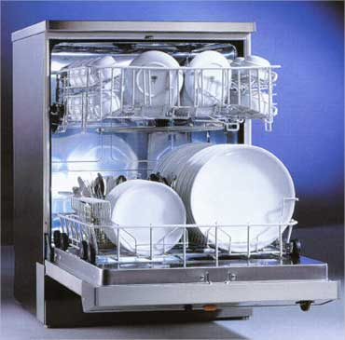

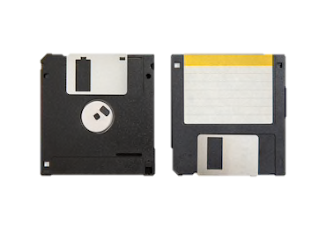

Labour-saving. Useful,

Modern, useless It was groundbreaking

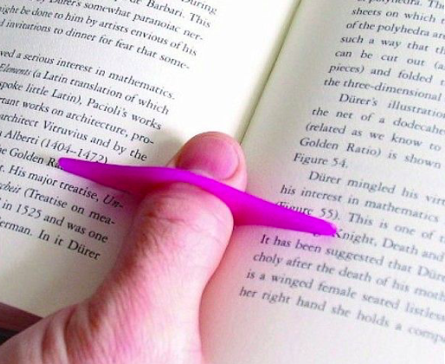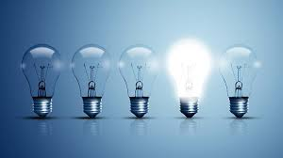

Curious, practical

important, marvelous,

WORD FORMATION

**1. Complete each phrase using a form of the word in bold.**

1. a great __**achievement**___ **achieve**
2. highly ___**benefits**_____ **benefit**
3. a ___**creative**____ person **create**
4. a recent ____**development**____ **develop**
5. an important __**discovery**______ **discover**
6. a major ___**improvement**___ in something **improve**
7. a useful ___**invention**___ **invent**
8. bring out a new ___**product**_ **produce**
9. a _____**scientist**____ fact **science**
10. a ____________ to a problem **solve**
11. a huge ____________ breakthrough **medicine**

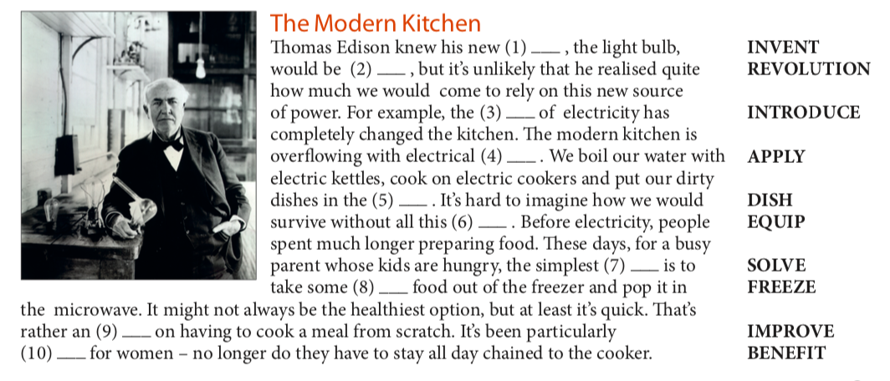**2. Complete the text using a form of the word in bold.**

**FORMATION**

PHRASAL VERBS

**Use the correct form of these phrasal verbs about technology to complete the sentences.**

break down · come on · come up with cut off · get through · look into · put in

1 If you ____________ an appliance like a washing machine, you install it.

2 If you ____________ a new idea for a product, you have an idea.

3 If you ____________ a new development, you investigate it.

4 If a car ____________ , it stops working.

5 If your electricity is ____________ , it is disconnected.

6 If you can’t ____________ to someone on the phone, you can’t connect to them.

7 If something has ____________ , it has developed or improved.

**Say which of the two statements below you agree with most, giving reasons. Consider the use of technology in some of these tasks:**

shopping **·** solving mathematical problems **·** writing essays **·** doing housework  
learning languages **·** making music **·** finding information **·** communication

1. I'm totally **in favour of** technology. Computers and labour-saving devices can help us do things more quickly – leaving us free to do more important things. Intelligent devices and things like smartphones are the future.
2. The more we let technology interfere in our lives, the more we move away from a natural existence. Technology and computers can help us do nearly everything but it is not always a good thing. We need to learn to do things, and to think, for ourselves.

|  |  |  |
| --- | --- | --- |
| BENEFITS | NEGATIVE ASPECTS | EXAMPLE |
| It helps us communicate |  | If stuck in traffic – can call on your mobile |
|  | Technology makes us lazy | Many people can’t do simple maths – always use a calculator |
|  |  |  |
|  |  |  |
|  |  |  |
|  |  |  |